CP3407 ASSESSMENT TASK 1: Project Plan

*Group 3 : Honey Zin, Evelyn Soong, Lea Annie Bonet*

**Project Management 1**

**Project Description 1**

**Project Planning and Scope 3**

**Project Design 4**

Architectural Design: 4

Database Design: 7

Interface design: 8

**Project Development 9**

**References 11**

## **Project Management**

GITHUB link: <https://github.com/Meveow/BzGrey>

Assignment done by and roles:

Evelyn - Project Description / Project Design  
Honey - Project Development / Project Design  
Lea - Project Planning and Scope / Project Design

## **Project Description**

The aim for this project is to introduce a new ICT solution that can help the elderly get comfortable with using technology. Currently, technology revolves around the world and it will only get more and more advanced day by day. Many elderly individuals have been taught to use technology, either by themselves or those around them. However, some of them aren’t so accepting of using technology and refuse to learn.

One of the many reasons include security concerns, raised by Lancaster (2018). The younger generation are very comfortable with and would rather shop online, online banking, or anything related with monetary transactions on the internet. However, the elderly are having trouble trusting a “third-party” to handle their money and information. They prefer to travel to the premises to do their tasks and deal with the business directly. Another reason stated by Lancaster (2018) is the concern of people losing their jobs. If businesses are resorted to moving their business from a physical store to online, the role of cashiers and/or receptionists are no longer needed. This can affect the economy, and the employment status of friends and family.

TYE Medical (2022) has brought up that the elderly struggle with memory due to age, and they have difficulty understanding complex concepts. It is much more difficult for the elderly to learn new things - thus many of them just reject the idea of learning new things and prefer to stick with the old traditional way of doing things. Remembering passwords and credentials is a challenge for them. Another issue related to age is vision loss, and sensitivity with lights. Digital screens can be bright and apps can have too many colors, which can overwhelm older users, and fonts can be too difficult for them to read.

To counter the challenges brought up, Dogtiev (2020) suggested making the user interface convenient by making the fonts larger for them to be able to read, and divide the contents into sections, making it easier to navigate. It was also advised to avoid complex features and gestures, for example adding a “Back” button to return to the previous page instead of adding a ‘slide-down’ menu. Just keep it simple with a tap, or a swipe. Colors must be carefully considered to ensure they are easy on the eyes. Mark (2017) suggested using high contrast colors like blue and yellow so that it is easier to differentiate parts of the screen (eg. buttons). Colors can affect emotions and feelings as well and Mark recommends the color blue as it has calming effects, helps with concentration, and reduces mental excitability.

Biometrics can help to authenticate users without having them to input their credentials. They can also prevent cyber-attacks (Kowtko, 2014) and assure any security concerns. If the elderly have a weak password, there’s a higher chance for attackers to identify the password, or if the elderly has a complicated password, the elderly themselves may forget it! Biometrics such as fingerprint, face ID, etc. can allow users to log in swiftly. This solution counters any possible memory loss of the elderly, and it is definitely more secure as it ensures the user logging in is the actual user.

According to Saunders (2018), technology has drastically changed the economy, employment, and the labor market. Many routine tasks have been upgraded from manual workers to automated technology - producing more output. Labor productivity increment led to economic growth, leading to an increase in job creation. Technology creates newer and more jobs.

Our proposed solution is to create an app for hospitals that is simple, clean, and fresh, with basic features. Basic features include what is needed to keep the user entertained and informed. We target older patients in the hospital. The reason for this is because unlike the older generations at home, there are caregivers or friends around them who are able to teach them how to use technology. However, patients in hospitals may not have anyone there that can take their time to sit down and teach the patient how to use technology, since medical staff are mostly there to help with their medical needs. Most patients tend to be lonely and unoccupied - especially the older ones since the younger generation is able to use their technological devices to keep themselves occupied. This is why the idea of a simple and basic app that serves the needs of the user is proposed.

The app will be created through Android Studio where the programming language Java is used. Because there is an emulator already embedded in Android Studio, the app can be directly tested within the software itself. The delivered materials include the whole Android Studio project.

## **Project Planning and Scope**

| User Stories | Solutions | Effort estimate (in days) |
| --- | --- | --- |
| Jake is a 75 yo man staying at hospital for chirurgical operations. It’s difficult for him to remember all medications he needs to take and when. | Calendar with a reminder for when he needs to take medication and where/when he has an operation scheduled |  |
| Beatrice is a 80 yo woman staying at the clinic for a long time because she’s recovering from covid19. Due to safety reasons, her family cannot visit her so she feels lonely because she can’t see her family. | Call features, so she is able to easily video call her family to keep a contact with the world and don’t feel lonely anymore |  |
| John is a 69 yo man who stays at the clinic for a long time. He is frustrated because he cannot catch up with what happens outside the hospital | Entertainment features with the news so John can keep up with world news |  |
| Karen is a patient at the hospital and she wants to view her health information in one page | Info patient page where Karen can see all her health informations |  |
|  |  |  |

## **Project Design**

### **Architectural Design**

* **Use Case view** : shows the requirement for the software

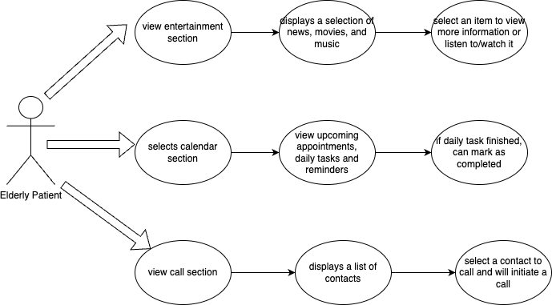

* **UML Component diagram** : shows the high-level abstractions in the software

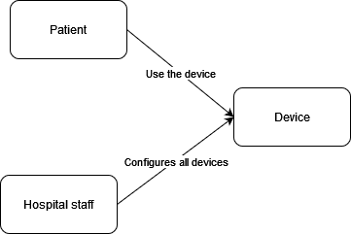

* **UML Behavior diagram** : shows the run-time interactions and processes of the software

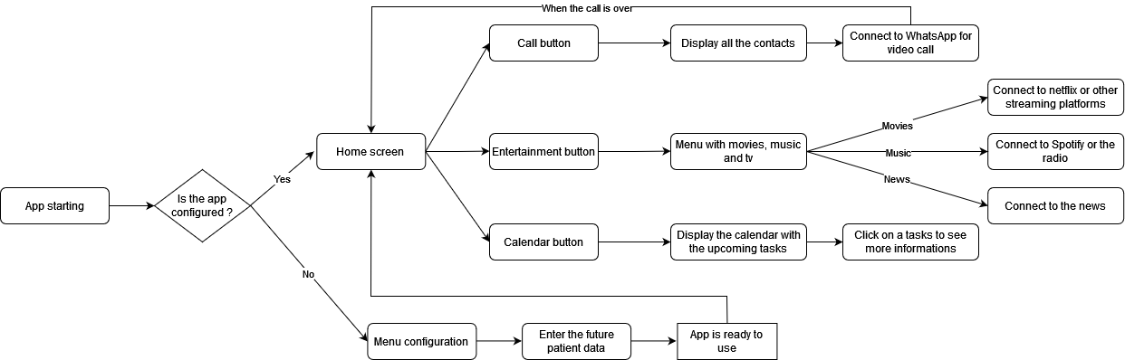

* **UML Object diagram** : shows how the software is coded

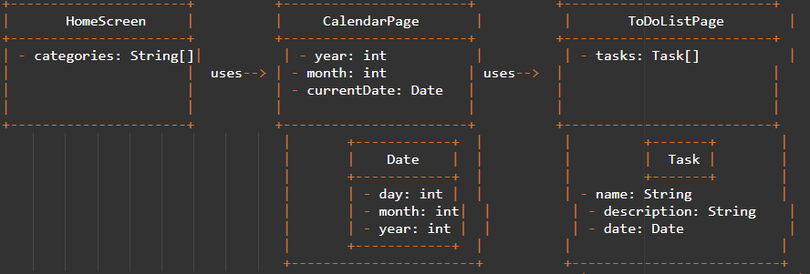

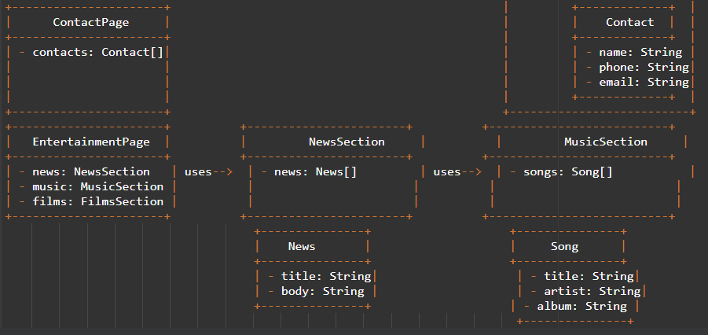

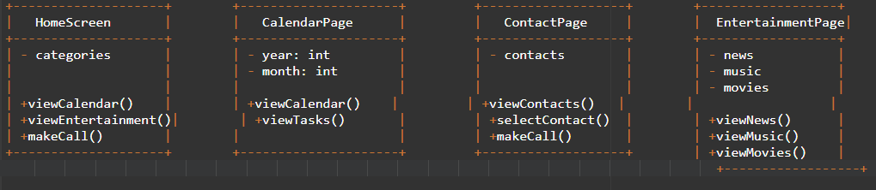

* **UML Deployment diagram** : shows how the hardware and software components are distributed across the organization

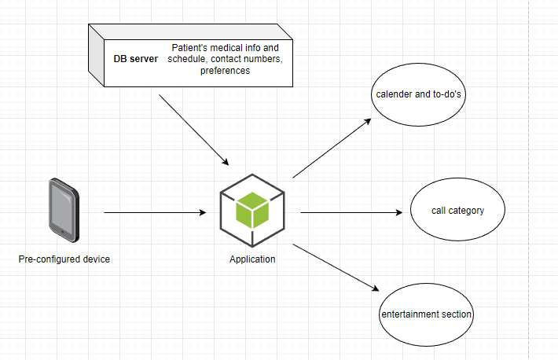

### 

### 

### 

### 

### 

### Database Design

This design is created by [draw.io](https://app.diagrams.net/) and it shows the information in the database for each category. Each category is color coded:  
Green: calendar and to-do list.  
Purple: entertainment section (news, music, movies)  
Yellow: contact section

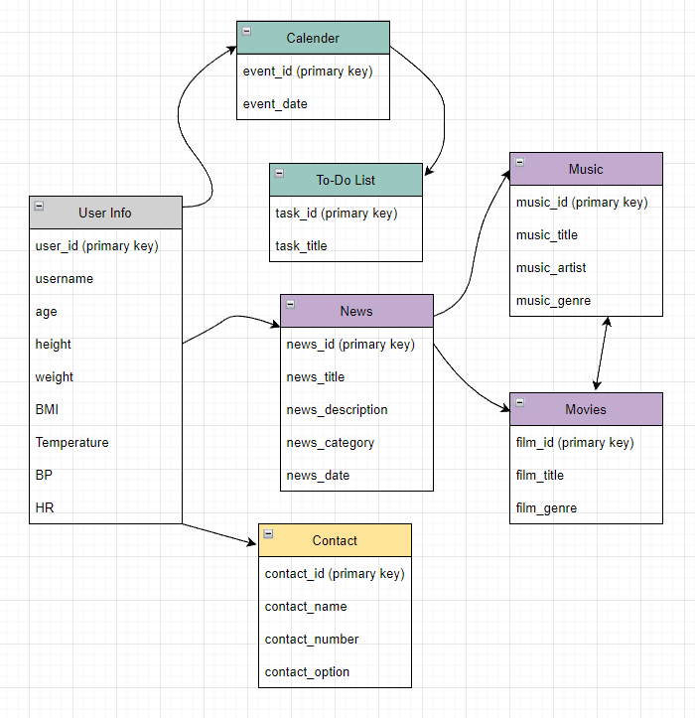

### Interface design

This design is a prototype of our system and is created using [Figma](https://www.figma.com/), a web-based design interface tool. There are a total of 8 pages consisting of home screen, patient info, calendar, call, entertainment section, movies, music, and news.  
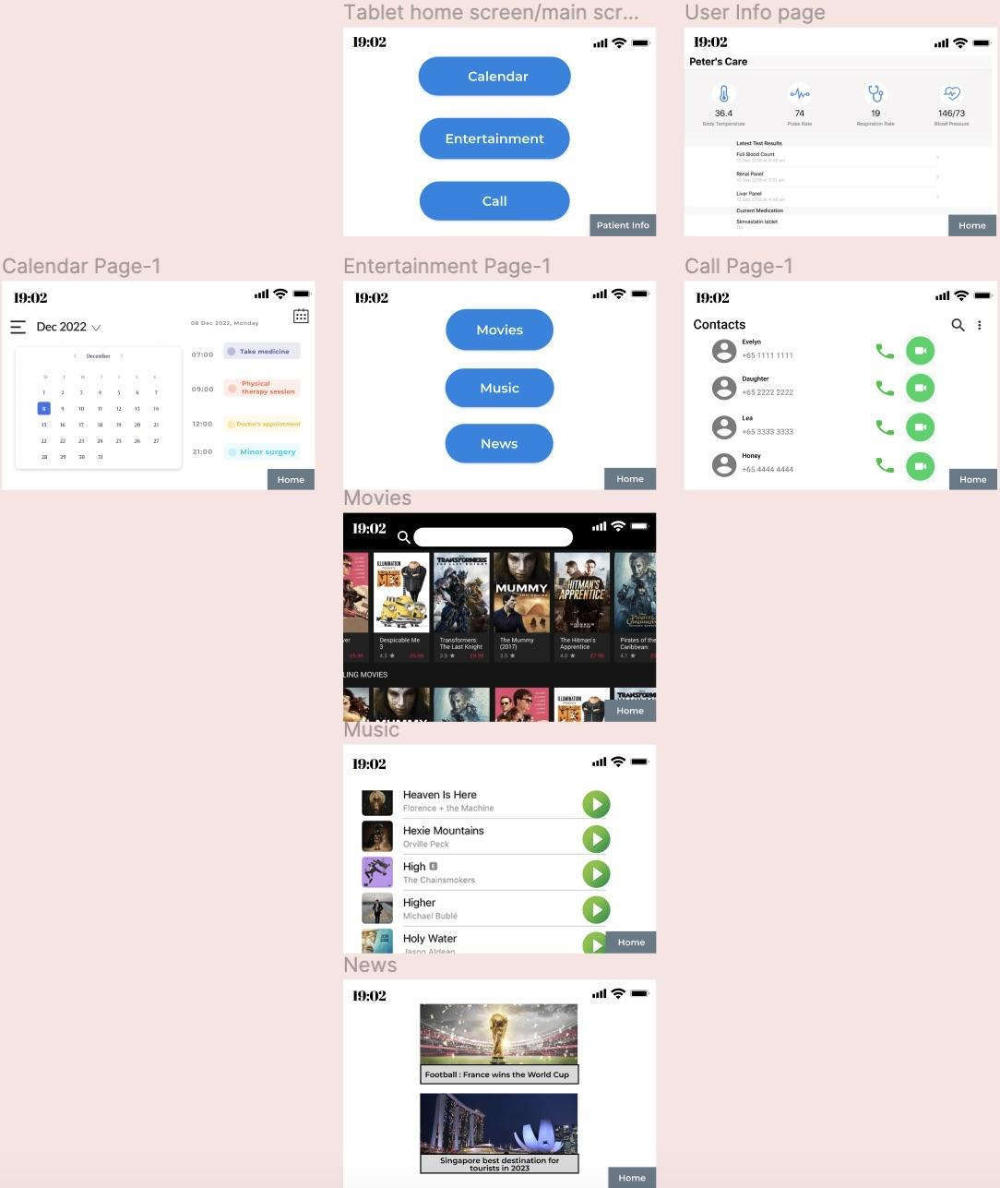

## **Project Development**

For our project, we have chosen Java as the primary programming language, as it is widely used and has a large community of developers. We are using Android Studio as our development environment, which provides a complete integrated development environment (IDE) for building Android applications. Android Studio includes a variety of tools and features, such as an emulator for testing applications, debugging tools, and support for multiple languages and frameworks. Java is highly recommended for developing Android applications due to its platform independence. As a result, the apps built on Java can function on any platform. Moreover, Java has its own runtime environment, known as Java Runtime Environment, and API. A considerable number of Android applications are created using Java, which is one of the widely used programming languages on GitHub. (Vaguez, 2022)

Android Studio also is a comprehensive platform that offers developers a wide range of features to design a superior quality mobile application for Android. These features comprise analytical tools to gauge security and app performance, along with App Indexing that facilitates easy access to the app via Google Search. It also offers a significant benefit by facilitating teamwork. One major example of this is its ability to enable developers to easily share and access code snippets, as well as merge changes from various team members, eliminating the need for excessive email and messaging exchanges. (Drexler, 2023)

We rely on Trello and Discord as essential tools for project management and collaboration. Trello provides an organized platform for project management where tasks can be tracked and monitored throughout the entire project lifecycle. With Trello, we can easily assign tasks, set deadlines, and track progress, enabling us to stay on top of our goals and deadlines.

Discord, on the other hand, serves as a communication and collaboration tool. It allows us to easily communicate and share updates with team members in real-time, no matter where we are located. We can use Discord for voice and text communication, file sharing, and screen sharing, which makes it an ideal platform for virtual meetings and remote collaboration.

By utilizing Trello and Discord for project management and collaboration, we can effectively coordinate our efforts and work together as a team to achieve our goals. These tools enable us to stay organized and efficient, while also fostering open communication and collaboration among team members.

For our project, we will also be using GitHub for code repositories and version control. As we will be using Java as our programming language and Android Studio as our development environment, GitHub will provide an efficient and effective way to manage our codebase and collaborate on code changes.

With GitHub, we will create private repositories to store and manage our code, which will be accessible only to authorized team members. GitHub's pull request and code review features will be utilized to ensure that code changes are thoroughly reviewed and tested before being integrated into the project, improving the overall quality of the codebase.

GitHub's branching capabilities will also be utilized to experiment with new features or changes without affecting the main codebase. This will help to keep the project organized and on track, as well as enable us to work on different features or fixes simultaneously.

Furthermore, GitHub provides several security features, such as two-factor authentication and access controls, that will help to ensure that our code repositories are secure and protected from unauthorized access.

Overall, by using GitHub for our project's code repositories and version control, we will be able to streamline our development process and ensure that our code is well-managed and secure.(Planning and tracking work for your team or project, n.d.)

During the early stages of development, it is crucial to create wireframes and prototypes that outline the basic structure and functionality of the product. For this purpose, we rely on Figma, which is a highly effective tool that allows us to build wireframes and prototypes in a user-friendly manner. Figma's easy-to-use interface and intuitive design features enable us to create simple, yet visually appealing models that provide a clear understanding of the product's overall layout and functionality. By utilizing Figma for our basic prototype development, we are able to streamline the design process and ensure that we have a solid foundation for the product before moving on to more advanced stages of development. These prototypes will be used to validate the project's feasibility and ensure that it meets the requirements of the stakeholders. Once the prototypes have been validated, we will move on to the alpha-release phase, where the application will be released for testing and feedback from a select group of users.

**Trello link :** <https://trello.com/b/EppA9j73/project-management>

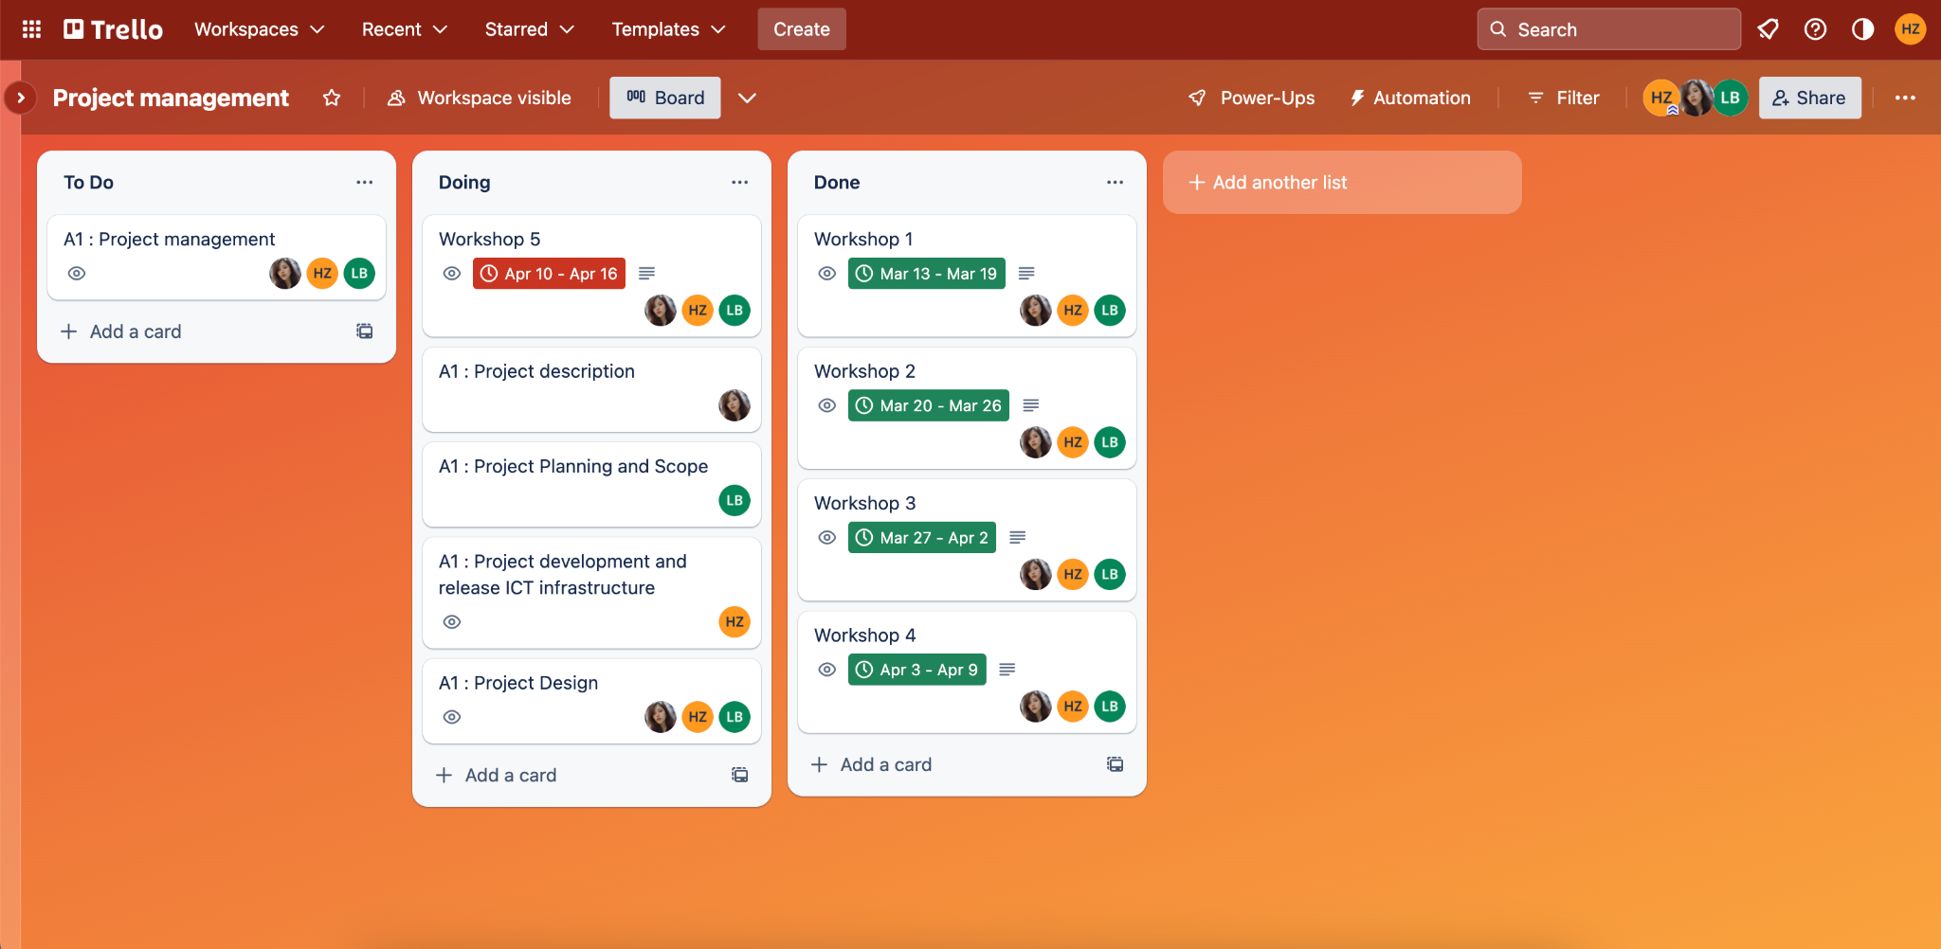

**Github Link :** <https://github.com/Meveow/BzGrey> (empty repository for now)

**Figma Prototype Link :** <https://www.figma.com/file/AeKnMURymECMOesLTbrB5R/CP3407?node-id=0-1&t=cXAJYYreelws2ydv-0>

## 

## **References**

Dogtiev, A. (2020, November 17). *Things to be taken care of when designing apps for the elderly*. Business of Apps. Retrieved from <https://www.businessofapps.com/news/things-to-be-taken-care-of-when-designing-apps-for-the-elderly/>

Drexler, O. (2023, March 23). *The pros and cons of Android Studio and App Tools.* 2023 | Hire flutter, mobile &amp; JS software devs | Pangea.ai. from <https://www.pangea.ai/dev-mobile-app-resources/the-pros-and-cons-of-android-studio-and-app-tools>

Kowtko, M. A. (2014, May). *Biometric authentication for older adults - researchgate*. Retrieved from <https://www.researchgate.net/publication/269298446_Biometric_authentication_for_older_adults>

Lancaster University. (2018, March 12). Why some older people are rejecting digital technologies. *ScienceDaily*. Retrieved from [www.sciencedaily.com/releases/2018/03/180312091715.htm](http://www.sciencedaily.com/releases/2018/03/180312091715.htm)

Saunders, A. (2018). *Technology's impact on growth and employment*. OpenMind. Retrieved April 20, 2023, from <https://www.bbvaopenmind.com/en/articles/technology-s-impact-on-growth-and-employment>

Mark, M. (2017, April 22). *Designing technology for seniors - color in user interfaces for elderly people*. User Interfaces for Seniors. Retrieved from <https://eldertech.org/color-in-designing-technology-for-seniors/>

*Planning and tracking work for your team or project.* GitHub Docs. (n.d.). Retrieved from <https://docs.github.com/en/issues/tracking-your-work-with-issues/planning-and-tracking-work-for-your-team-or-project>

TYE Mecial. (2022, June 6). 8 Reasons Seniors Can Struggle with Technology. *TYEMedical.* Retrieved from <https://tyemedical.com/blog/8-reasons-seniors-can-struggle-with-technology-and-tech-tips-to-overcome/>

Vaguez, L. (2022, August 31). *Kotlin vs. Java for Android Development.* LogRocket Blog. Retrieved from <https://blog.logrocket.com/kotlin-vs-java-android-development/>